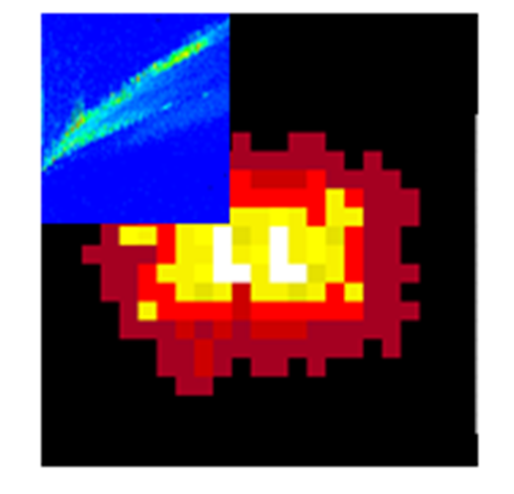

**IM-MSIC User Notes**

Daniela Mesa Sanchez1, Steve Creger1[1],Veerupaksh Singla2†, Ruwan T. Kurulugama3, John Fjeldsted3, Julia Laskin1

1Department of Chemistry, Purdue University, West Lafayette, IN 47906, USA

2Department of Chemical Engineering, Indian Institute of Technology Bombay, Powai, Mumbai, Maharashtra 400076, India

3Agilent Technologies Inc., Santa Clara, CA 95051, USA

Contents

A. Before you begin 3

1. Install the latest version of Python 3 3

2. Install Skyline-daily [1] 5

3. IM-MSIC installation and settings 11

4. Skyline Settings 15

B. Generating a mass list 17

1. Untargeted: Mass Profiler 17

2. Targeted: mass list 21

C. Scripts 22

1. IM-MSIC 22

2. Absolute comparison 25

3. Outlier correction 27

3. RBG Overlay 29

3. Change Aspect Ratio 31

D. Troubleshooting 31

1. Software versions 31

2. Path 32

3. Raw Data Directory Properties 33

# A. Before you begin

## 1. Install the latest version of Python 3

1. For Microsoft Windows, visit [python.org/downloads/windows/](https://www.python.org/downloads/windows/). Scroll down to the ***Stable Releases*** section and download the latest version of Python 3 for your system (check section **D.1**). Downloads for other operating systems can be found at [python.org/downloads/](https://www.python.org/downloads/).

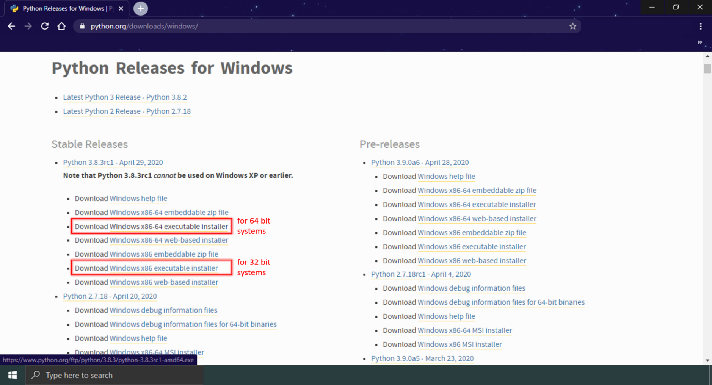

1. Open the downloaded installer file, and select ***Run*** if a ***Security Warning*** appears.

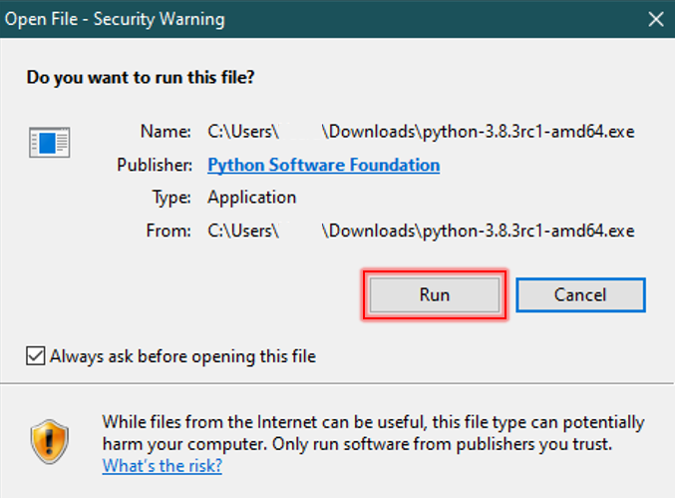

1. The setup window will appear. Check the ***Add Python 3.x to PATH*** at the bottom of the setup window. Then click on ***Install Now***. **DO NOT** use the ***Customize installation*** option unless you know what you are doing.

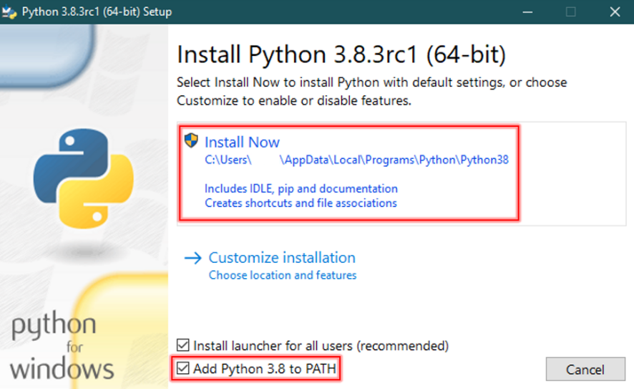

1. Wait for a few minutes as Python is installed and the ***Setup Progress*** bar is displayed.

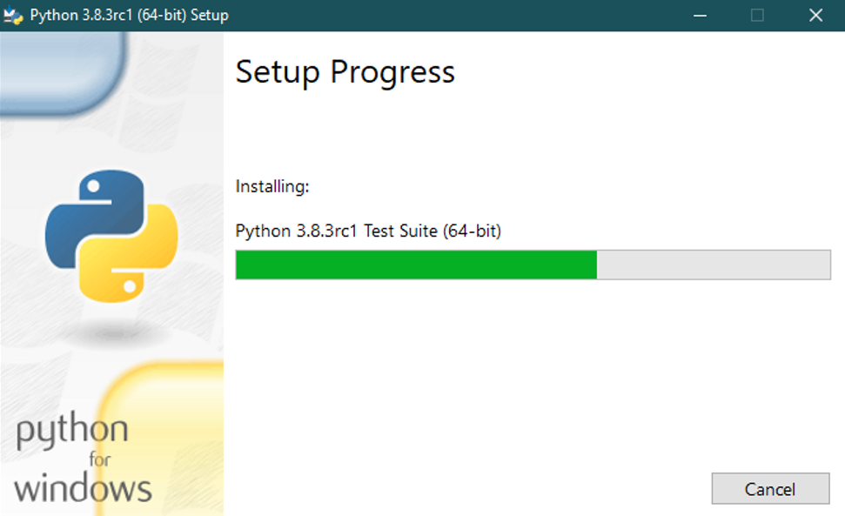

1. Once the setup is complete, the ***Setup was Successful*** window will appear. Click on the ***Close*** button at the bottom of the window. You have successfully installed Python 3.

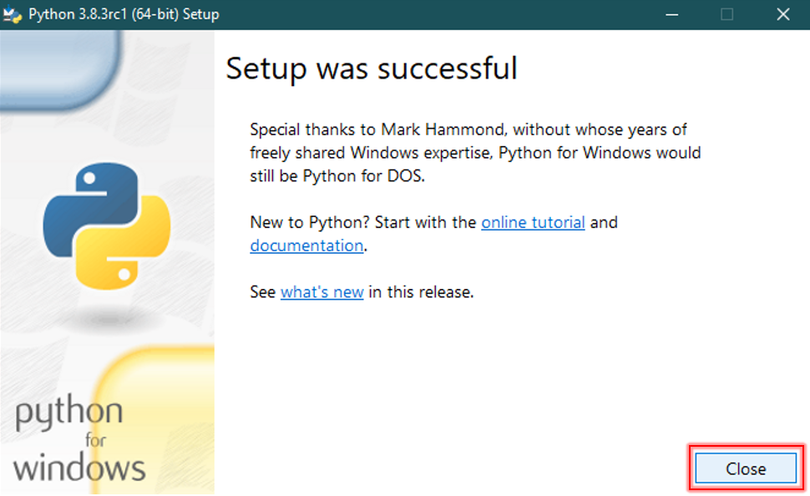

## 2. Install Skyline-daily [1]

1. Visit [skyline.ms/project/home/software/Skyline/daily/register-form/begin.view?](https://skyline.ms/project/home/software/Skyline/daily/register-form/begin.view?). You will need to login to the Skyline website in order to download the setup file. At the bottom of the webpage, click on ***sign in*** if you already have a Skyline account, or select ***sign up*** to create a new account.

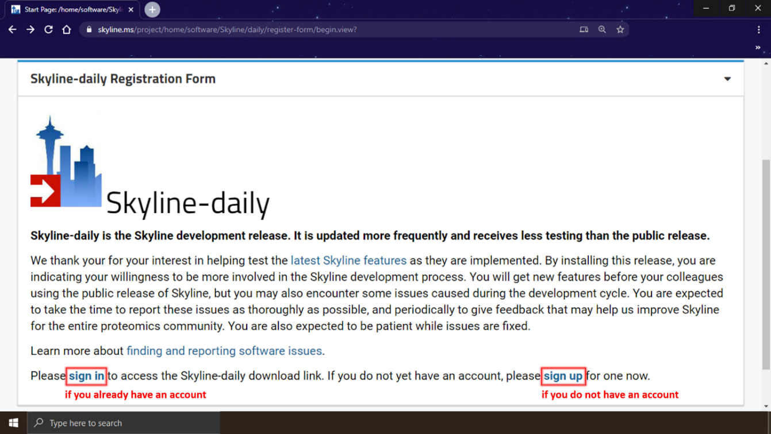

1. Once you have logged in, the download page will appear. Click on ***I Agree*** and ***Install Skyline-daily*** button will appear; click on the ***Install Skyline-daily*** button to download the setup file. Also download the ***SkylineDailyRunner.exe*** file which will be used later (in section **B.6**).

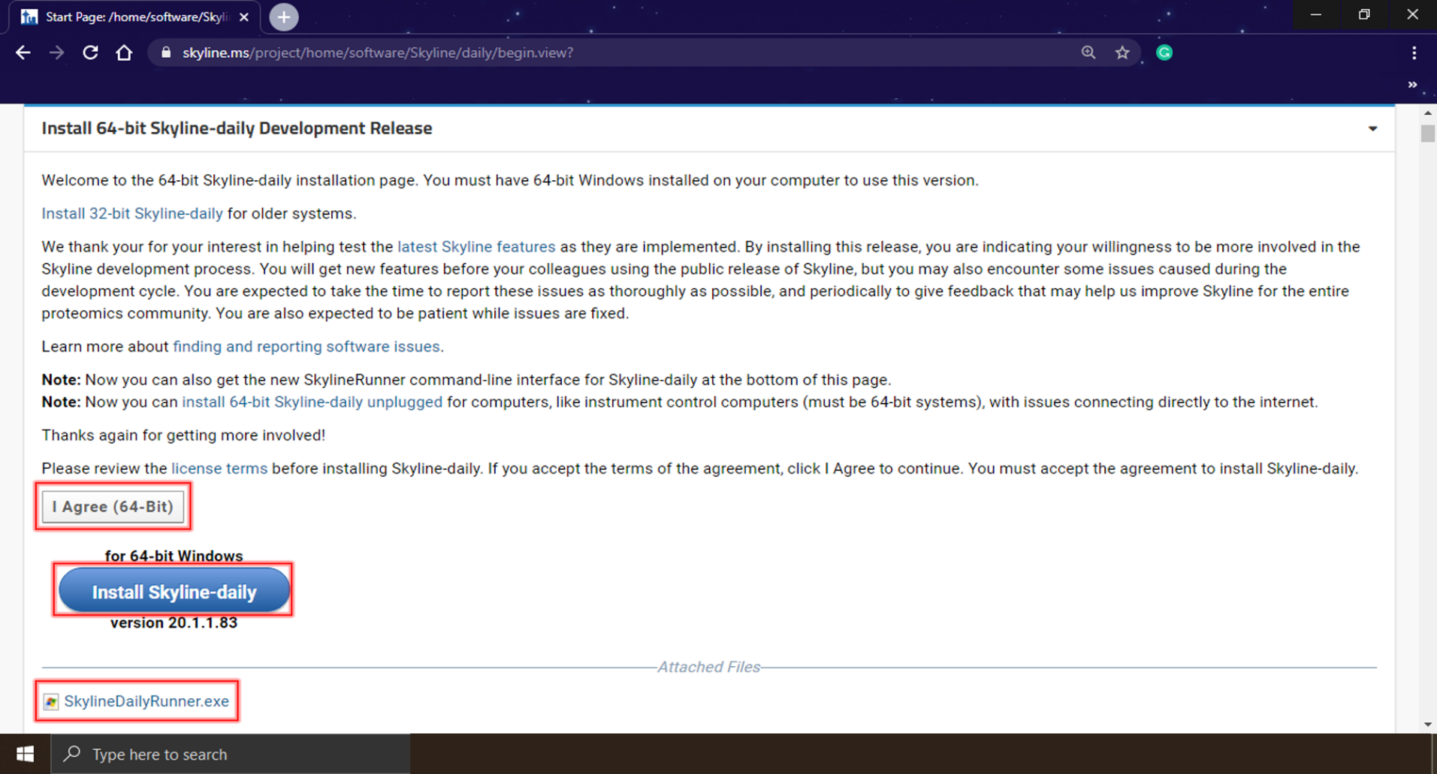

**[1]** MacLean B, Tomazela DM, Shulman N, et al. Skyline: an open source document editor for creating and analyzing targeted proteomics experiments. Bioinformatics. 2010; 26(7):966‐968. [doi:10.1093/bioinformatics/btq054](https://doi.org/10.1093/bioinformatics/btq054)

1. Open the setup file downloaded in the previous step. If a ***Security Warning*** window appears, select ***Run***.

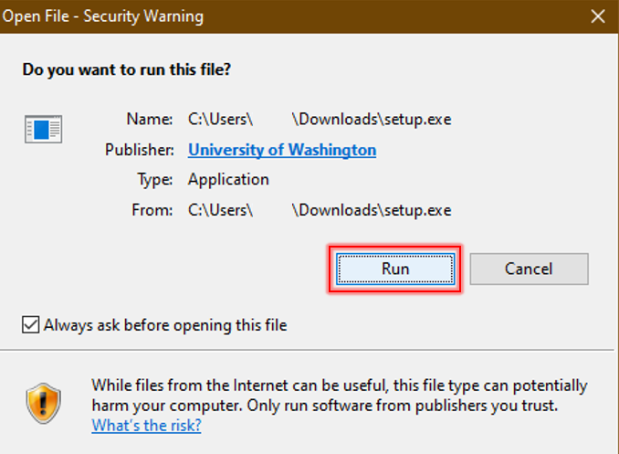

1. The setup will connect to internet. This is an internet based setup, make sure you have a working internet connection throughout the setup.

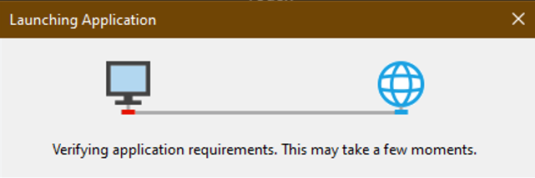

1. If a ***Security Warning*** appears, click on ***Install***.

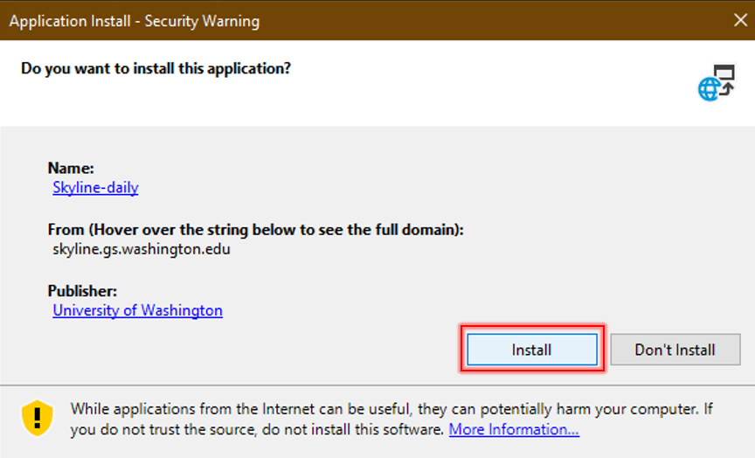

1. The setup will download and install Skyline-daily to your PC.

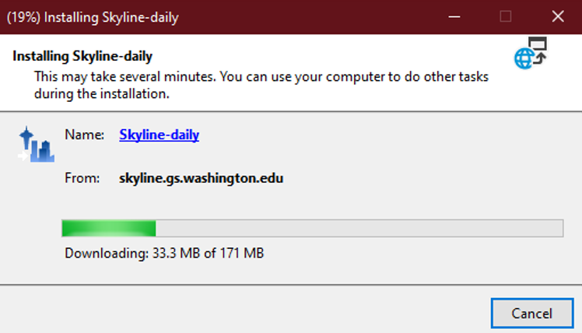

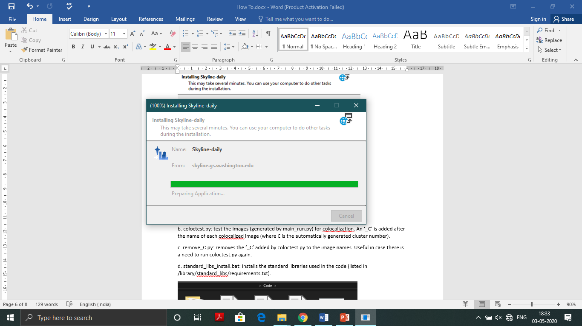

1. Select ***Run*** if a ***Security Warning*** window appears.

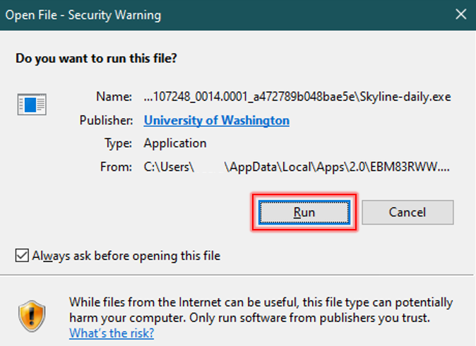

1. Pick your desired interface style, then click ***OK*** on the ***Default UI Selection*** window; you may change the default UI if you wish to. Close the Skyline-daily Start Page. You have successfully installed Skyline-daily.

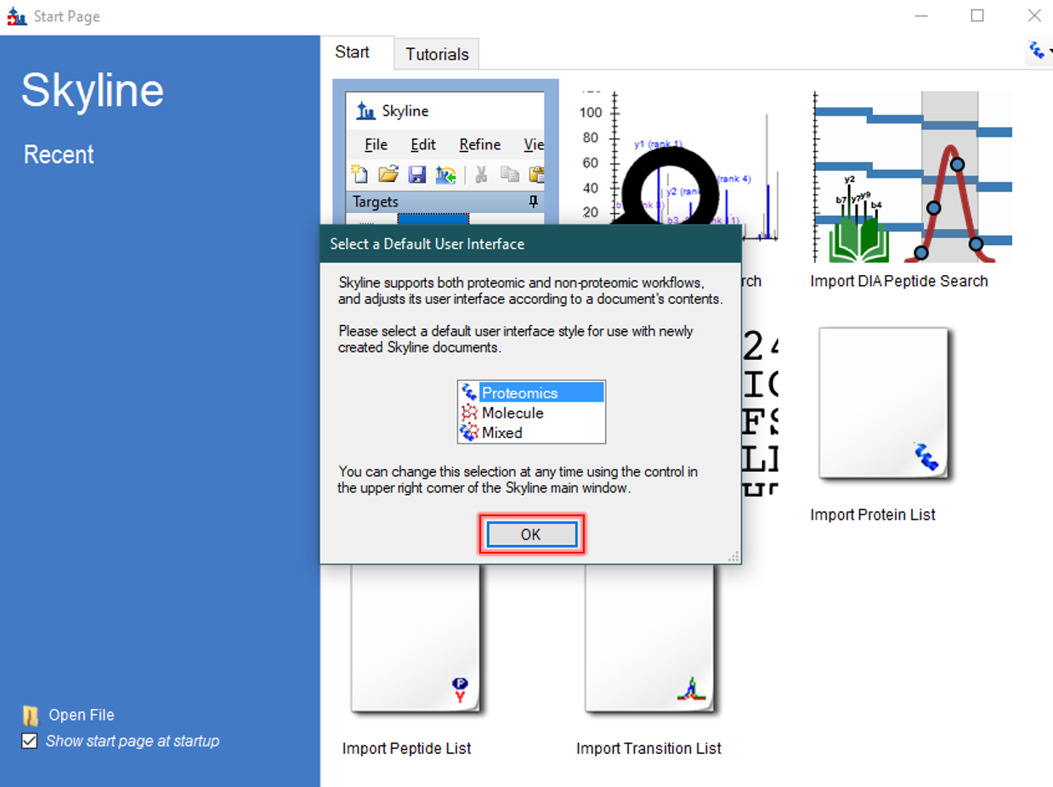

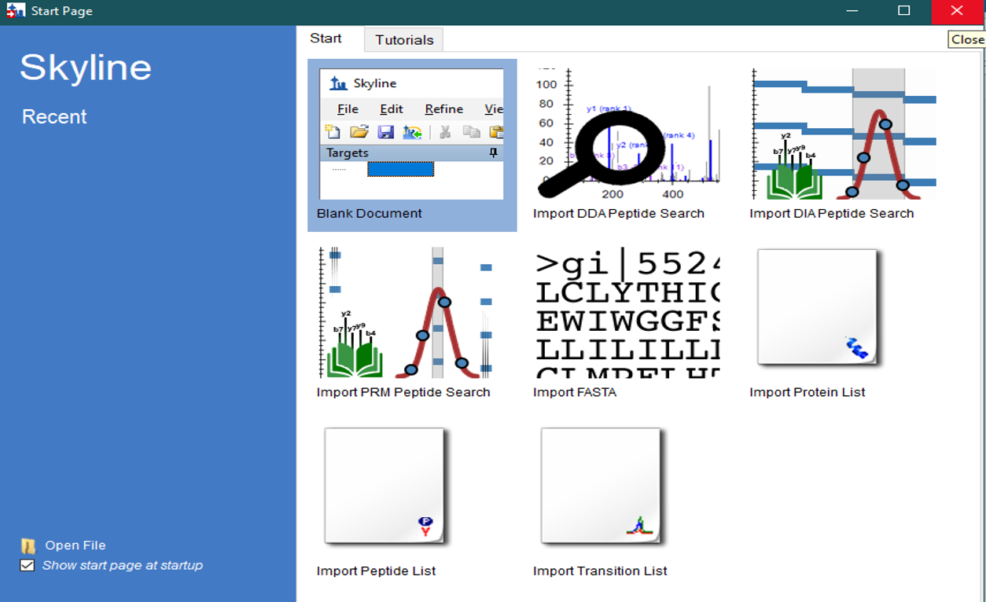

## 3. IM-MSIC installation and settings

1. Download the MSIC Master folder and copy it into the C: drive. (This way path defaults will work, however if you want to change it refer to f).

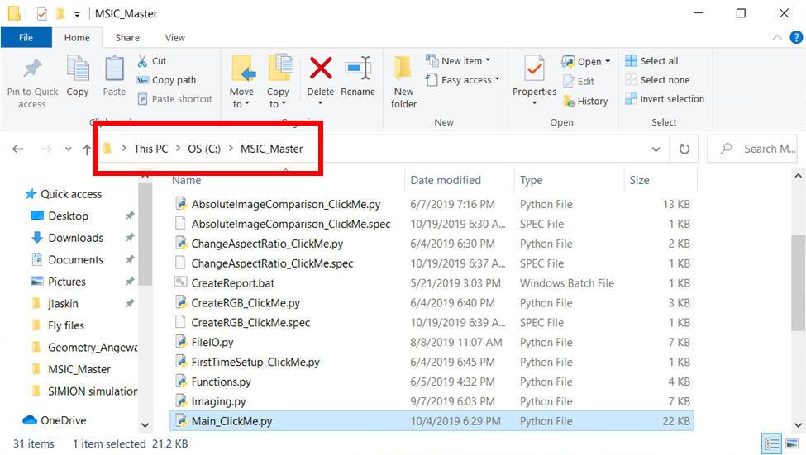

1. Run the ***FirstTimeSetup_ClickMe.py*** (ctrl + o or File>Open) and then run it

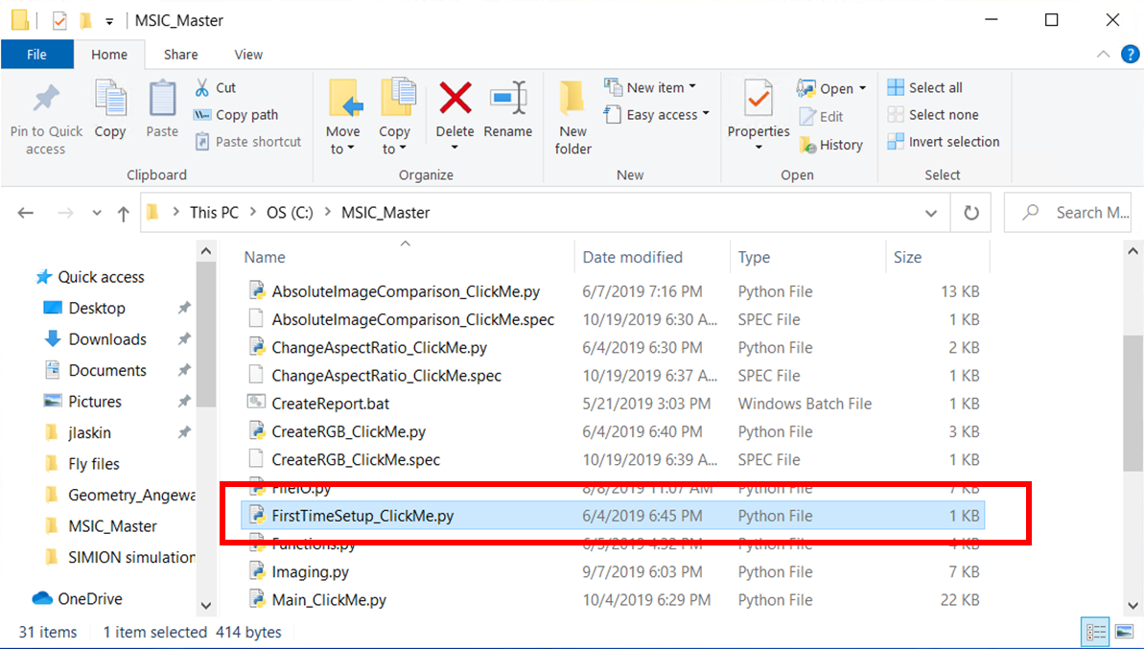

1. From here you can also access the ***SETTINGS.txt*** in the ***MSIC_Master*** folder

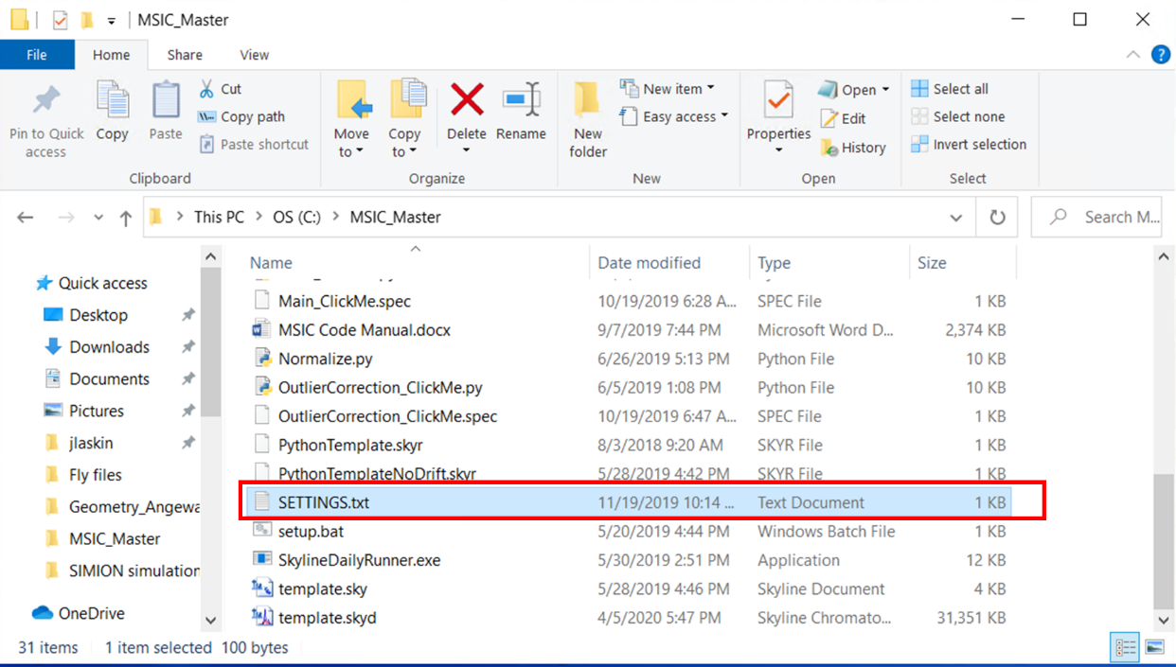

1. Change the text document for the desired settings. You will also be prompted to do this anytime you launch one of the scripts.

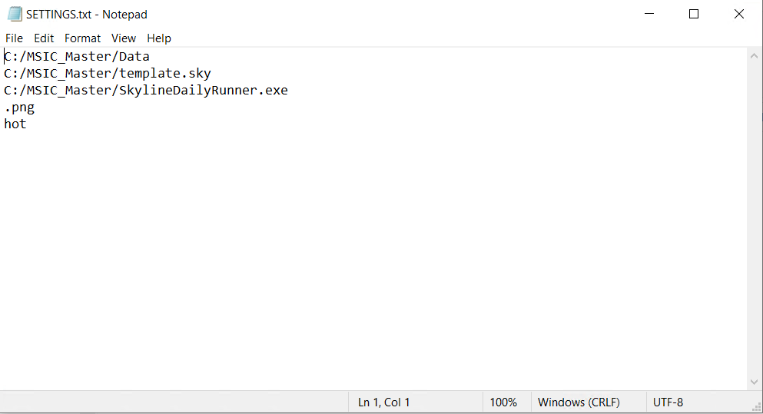

|  |  |  |  |
| --- | --- | --- | --- |
| Line # | Setting | More Info | Example |
| 1 | Home Directory | Where post-processed images are saved | C:/MSIC_Master/Data |
| 2 | Skyline Template Path | This should already be in he MSIC_Master folder | C:/MSIC_Master/Template.sky |
| 3 | SkylineRunner Path |  | C:/MSIC_Master/SkylineDailyRunner.exe |
| 4 | Image Format | This must be an RGBA-compatible format | .png / .tiff (no jpeg) |
| 5 | Color Map Style | Adjust the color of the images produced via Main, Outlier, or AIC methods | hot, magma, plasma, viridis, etc. (the full list of colormap options can be found [here](https://matplotlib.org/examples/color/colormaps_reference.html)) |

## 4. Skyline Settings

In case of any problems with Skyline, follow the steps below. If the problems persist, reinstall Skyline-daily and replace SkylineDailyRunner.exe with the latest version (see sections **A.2** and **B.6**).

Make sure you have Skyline installed on your PC before you proceed.

1. From the home directory of the workflow, proceed to the directory - ***/library/tools/skylinetools***.Double click on ***template.sky***. Skyline will launch and load template.sky. On the toolbar at the top, click on ***Settings*** and then on ***Transition Settings***.

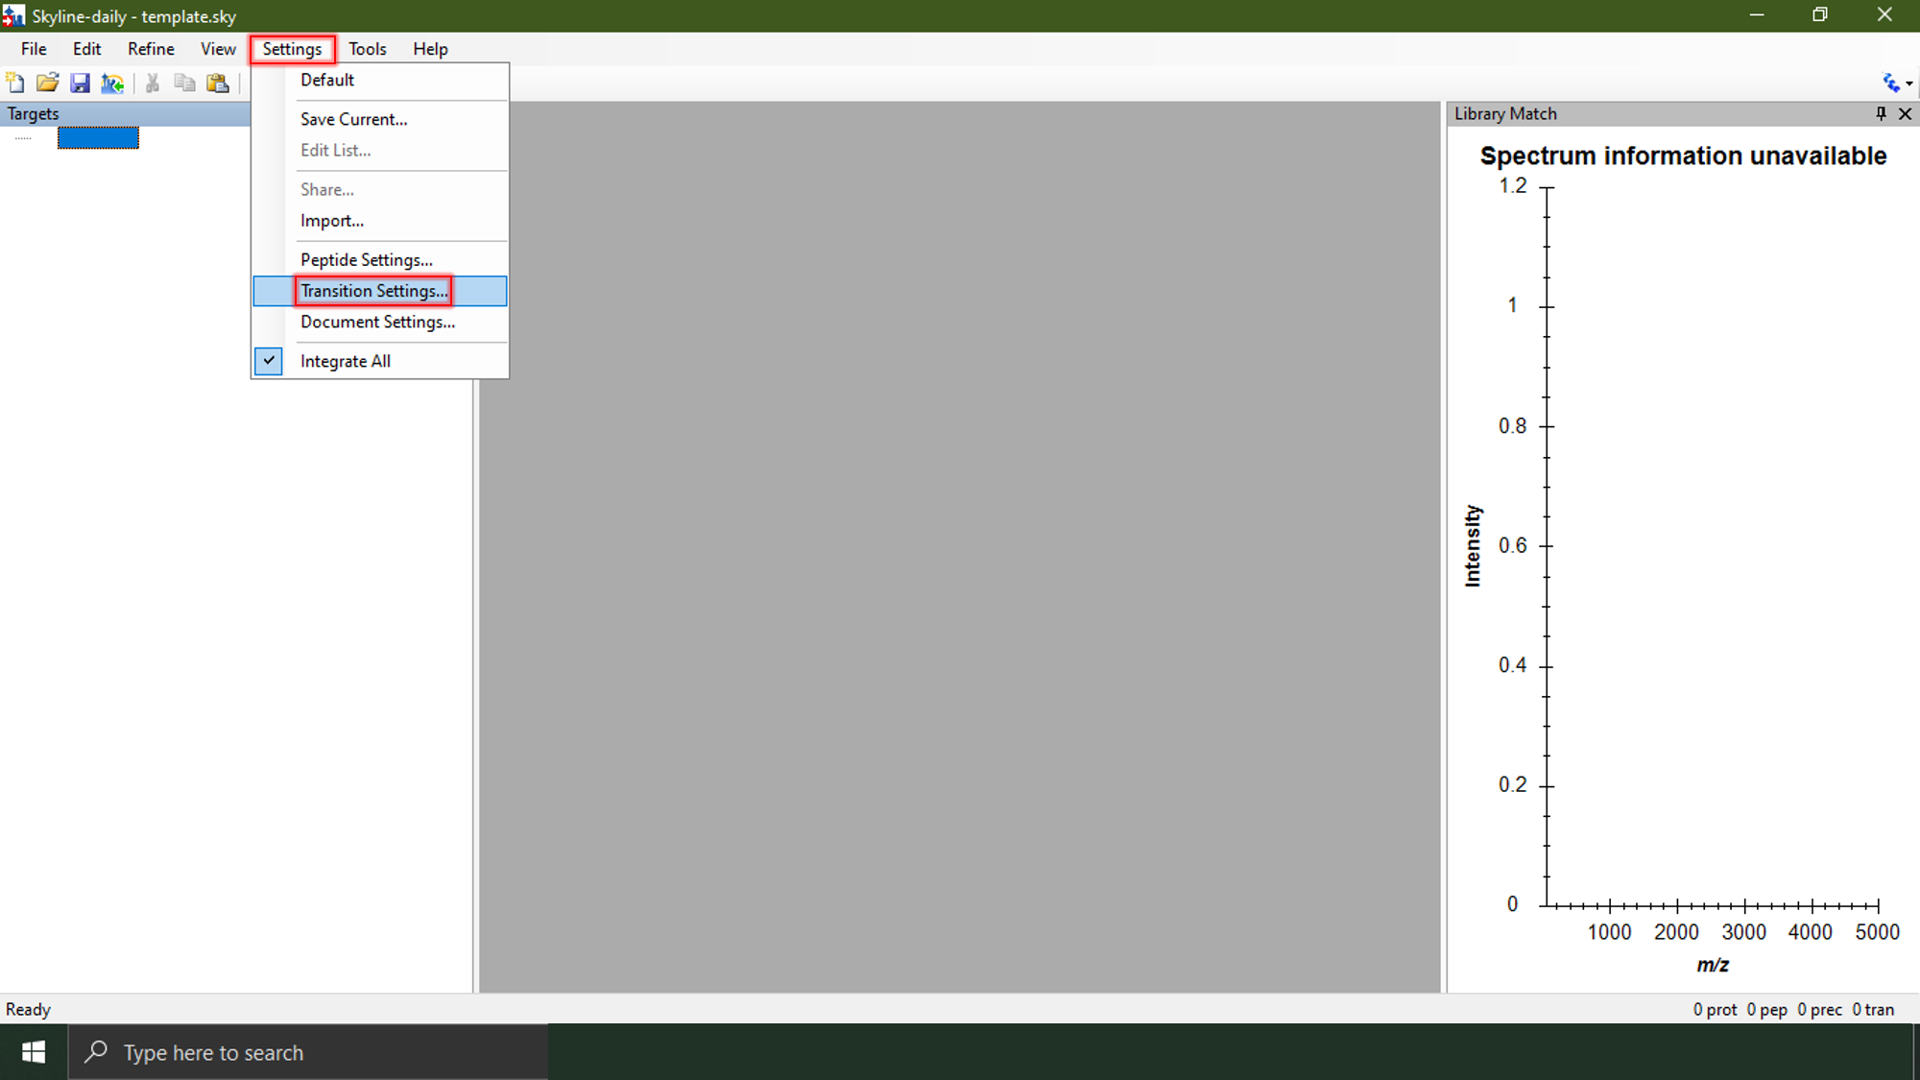

1. The ***Transition Settings*** window will open. Ensure that these values match the ones shown below for all the tabs. In the ***Instrument*** tab, you can adjust the Min m/z and Max m/z values according to your data and mass profiler settings. Please ensure your ***Full Scan*** settings reflect your instrument. Once you are finished adjusting all the settings, select the ***OK*** button and press ***ctrl + S*** to save these settings.

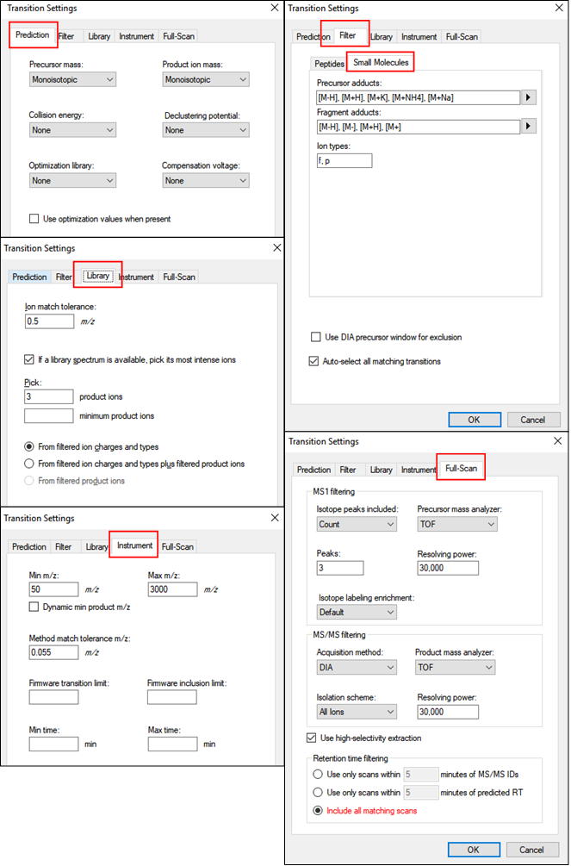

c. If you have more than one instrument, you can save more than one template with different ***Full Scan*** settings but make sure you also change the corresponding setting for the template path.

# B. Generating a mass list

## 1. Untargeted: Mass Profiler

1. File -> Create Project  
   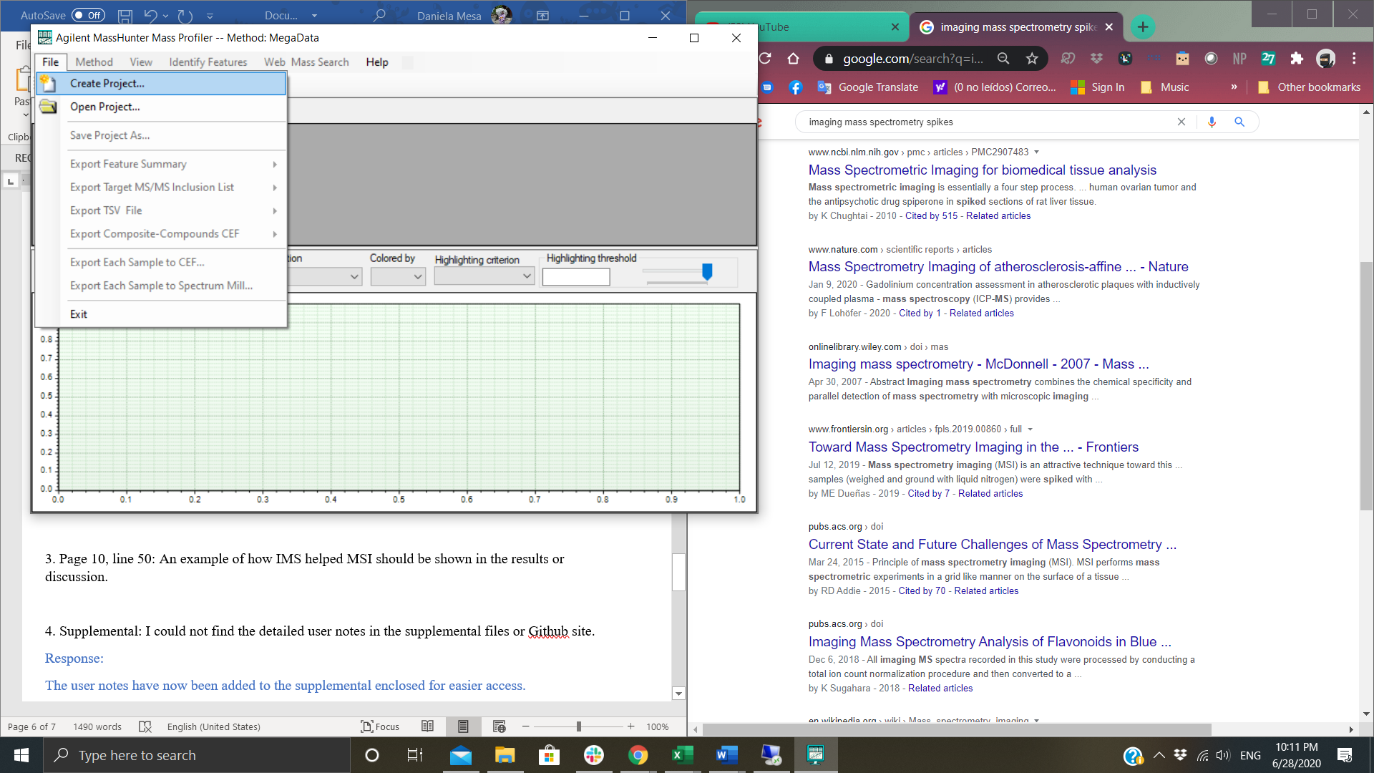
2. Change ‘Number of groups’ to 1.

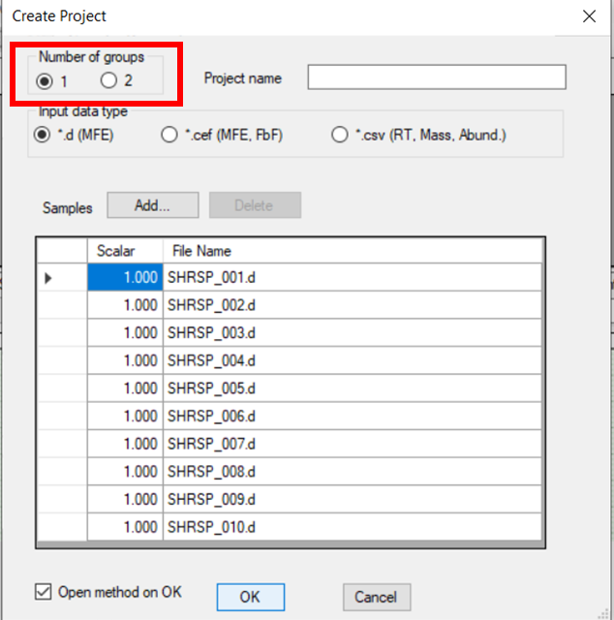

1. Name this project the same as the folder in which your raw data is stored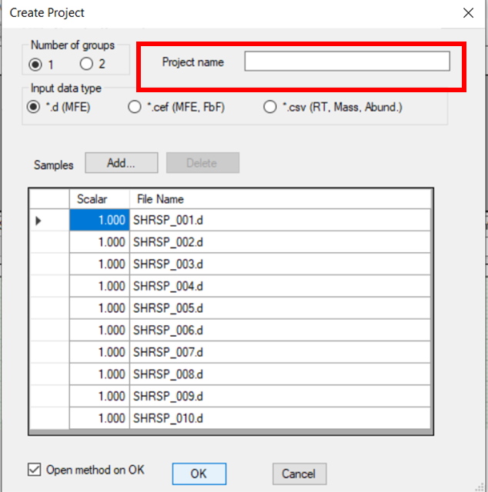
2. Click the ‘Add’ button. A browser window will pop up. Add some or all of your data lines. More lines will take longer to process but will give you a better feature list if your sample is very heterogeneous. If your sample is homogeneous a couple of representative lines should be fine.   
   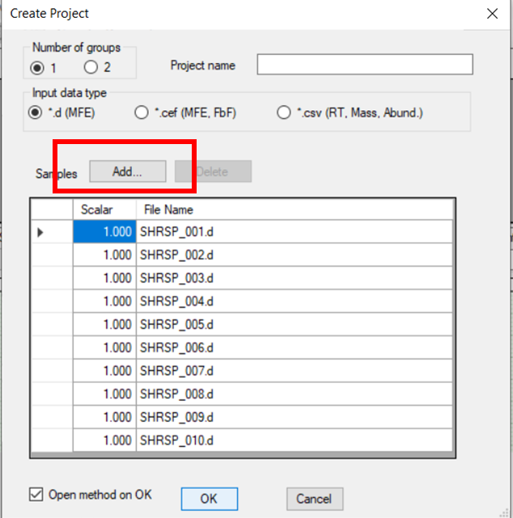
3. Run the method via ‘Open method on OK’ option or by clicking the green play button

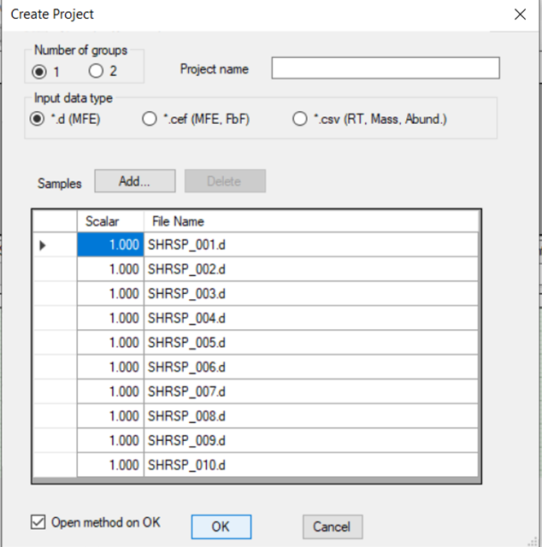

1. Toggle the method parameters according to your preferences. Below are some starting settings. Please refer to the Mass Profiler help menu for clarification into each of the parameters. It is very important that the ***infusion data*** input data filter is selected. You may use the ***Q-score*** to get rid of low quality peaks, however please beware the Q-score metric is designed to optimally work with chromatographic peaks. The parameters displayed below are only common parameters. You may display all parameters using the toggle at the bottom of the window. Once you have finished adjusting your desired parameters ***Run*** the method.

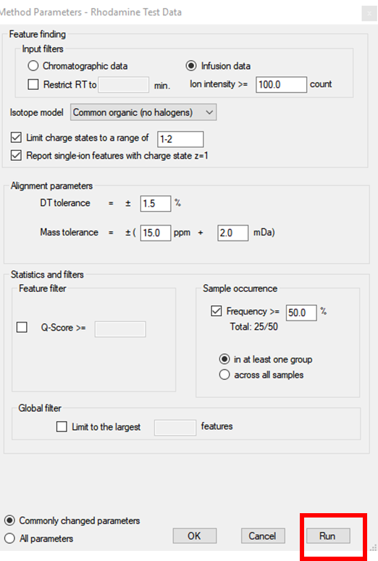

1. Once the extraction has finished export the feature list by clicking ***File*** -> ***Export Feature Summary*** -> ***From Table*** – ***All Features***

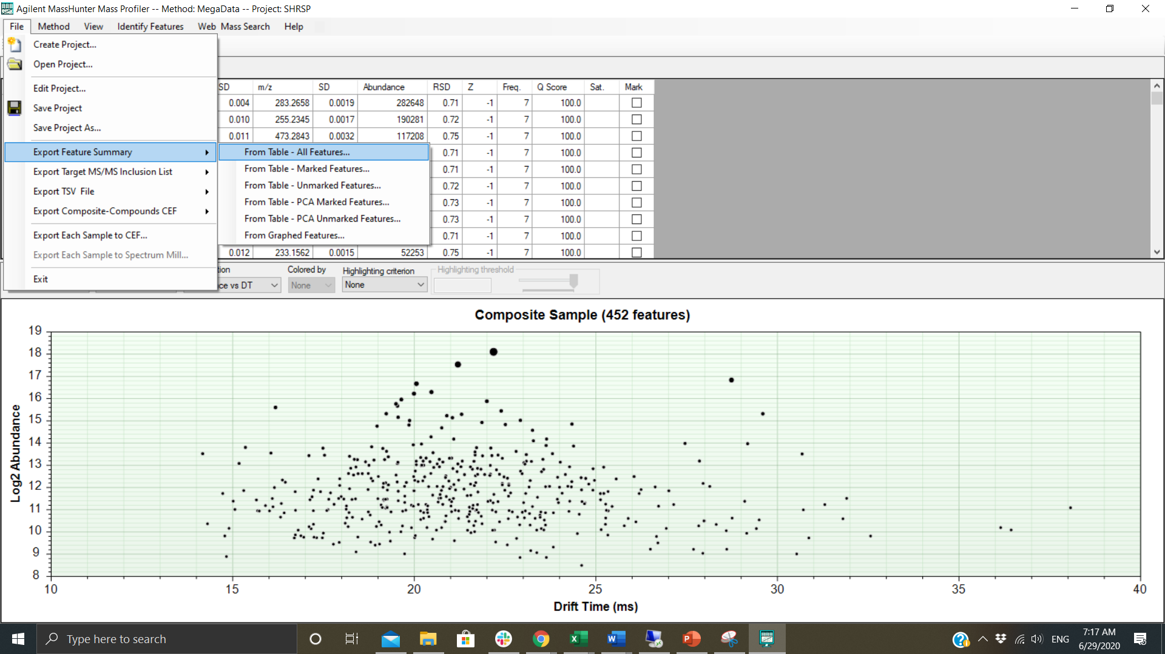

1. Save the feature summary in the same folder as your raw data

## 2. Targeted: mass list

1. If you would like to generate your own mass list you will need to create a tab separated file with a .csv extension. This transition list has very specific nomenclature. It should be named ***folder_TL.csv***, where folder is the name of the folder containing your data and the transition list.
2. Sample mass lists can be found in the ***MSIC_Master*** folder under the ***sample files.zip*** folder
3. You may edit these files in excel, you will then need to save them as a Text (tab delimited) then rename it to include a .csv extension

# C. Scripts

## 1. IM-MSIC

Creates IM-MS images from raw data and a Mass Profiler export. Takes as input: 1+ data folders (raw .d IM-MS data, Mass Profiler export). Outputs image folder within the data folder, contains an image and txt file for every peak in the experiment

1. Click the ***Main_ClickMe.py*** file in the ***MSIC_Master*** folder

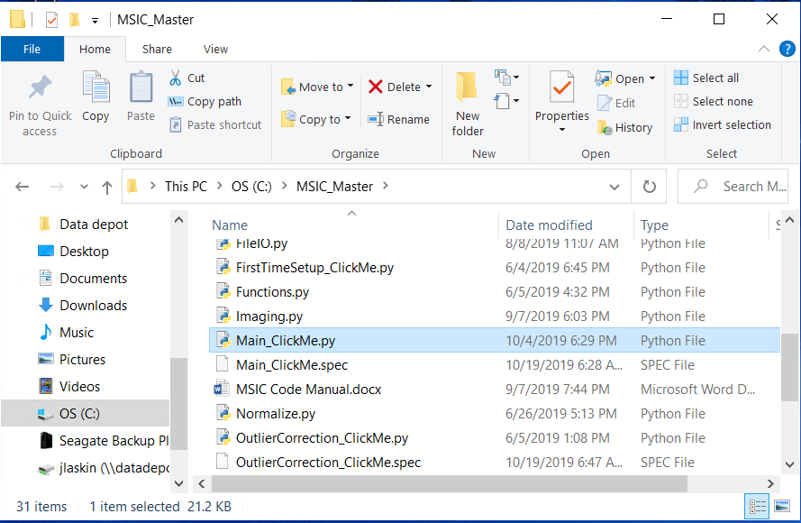

1. Enter ‘y’ to change the settings ‘n’ to use the default settings already in the ***SETTINGS.txt*** file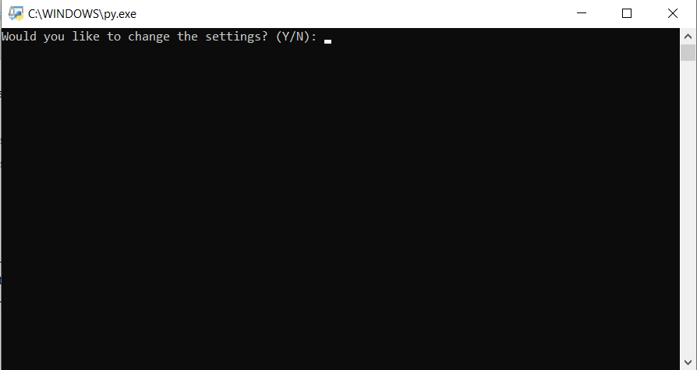
2. A new file explorer window should pop up. Select data folders, each data folder must contain: raw IM-MS data (Agilent .d format or others supported by Skyline) and a mass list (exported Mass Profiler Feature Summary or targeted mass list, please refer to

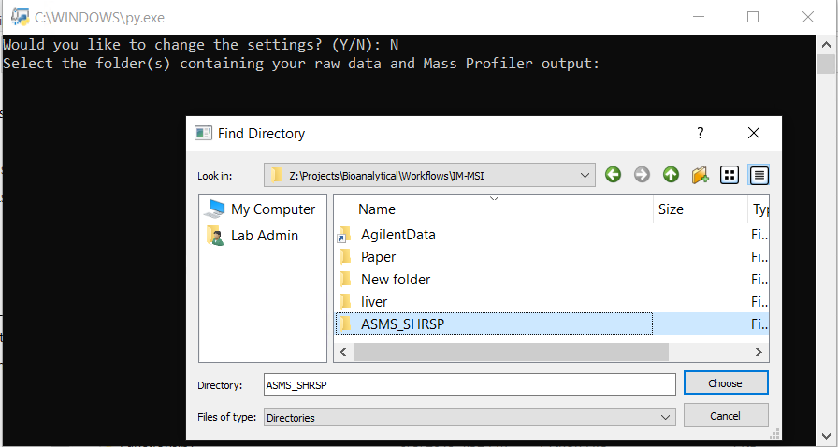

1. Enter your desired aspect ratio(s) as prompted. This is important for MSI techniques in which pixels are not necessarily square.

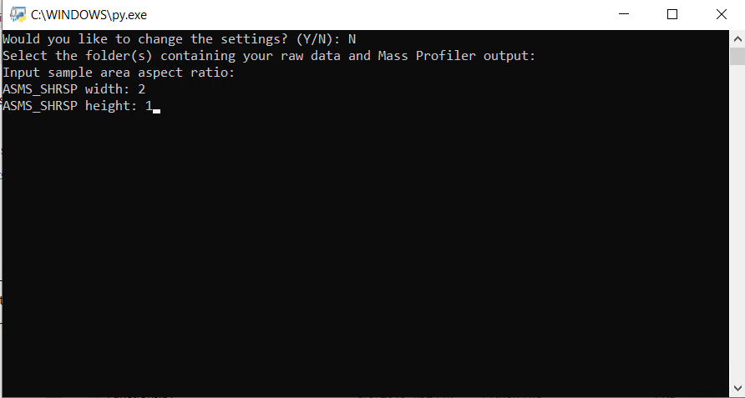

1. Select which type of normalization you would like for your images

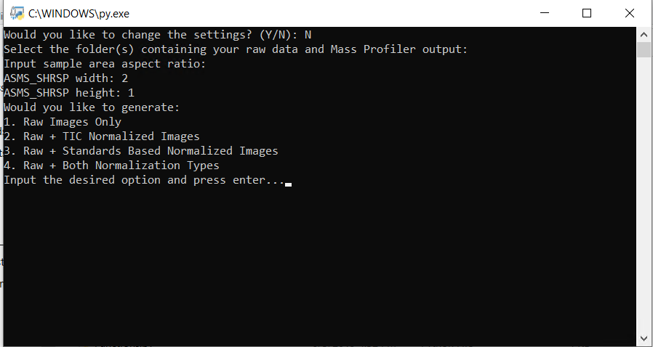

1. If you select standard normalization, input the feature IDs (from the mass list) of your desired standards for normalization.

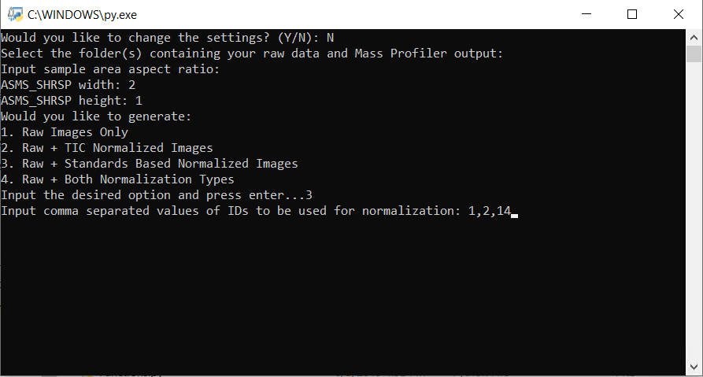g. Select if you would like to use ion mobility separation.

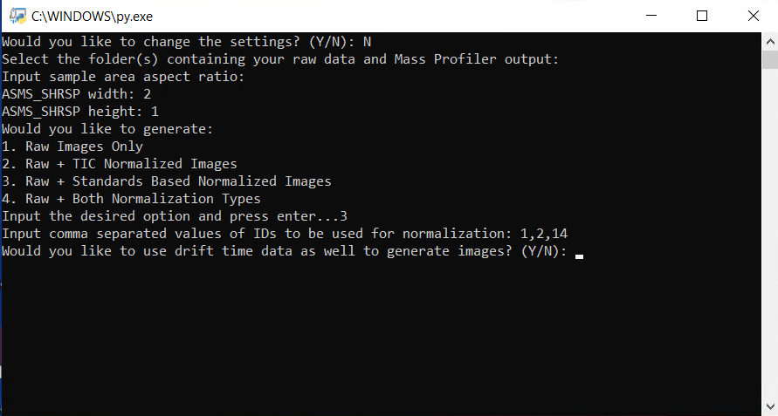h. Sit back, this will take somewhere between 10 and 60 minutes. Images will be saved to the data folder.

## 2. Absolute comparison

Allow for comparison between images by setting their color scale to a common range

* 1. Launch the ***AbsoluteImageComparisson_ClickMe.py*** file from the ***MSIC_Master*** folder

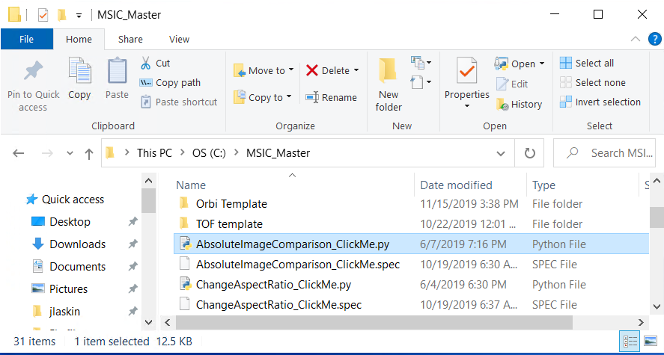

* 1. Select whether you will like to compare 2+ txt files corresponding to MSIC images or 2 folders of experimental data that has already been processed by *Main_ClickMe.py*

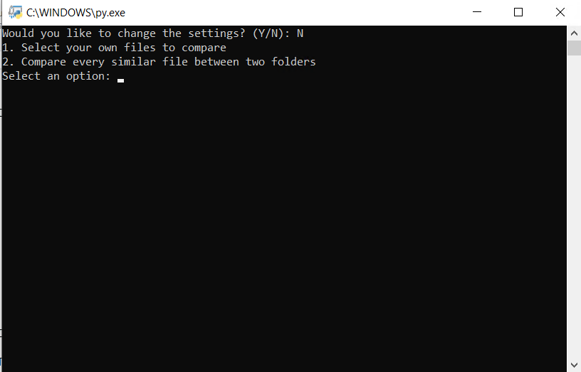

* 1. If 1, use the pop up window to select two or more txt files. If 2, select the first folder then a second pop up will allow you to select a second folder.
  2. Select if you would like to save your results (the newly normalized images) or if you would like to add more images for a common normalization. Saved images will be saved in the data folder specified in the settings. You can change this when first launching the script or in the text file (A3).

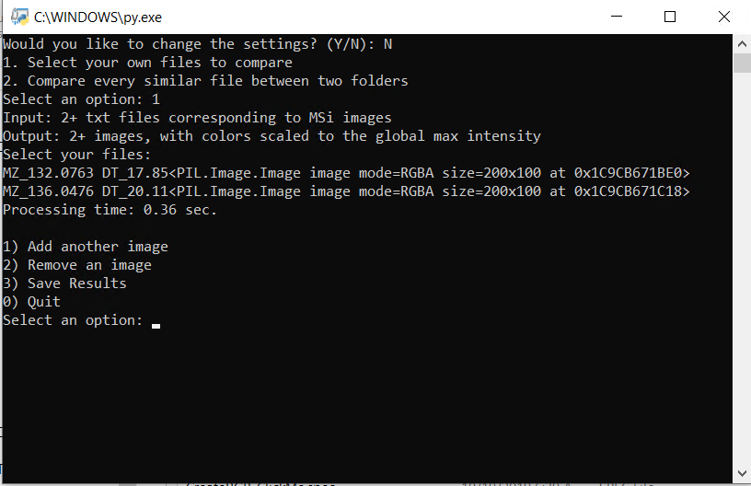

## 3. Outlier correction

Post-processing tool. Must have already generated images. Utilized to remove spikes from images for more defined images. Three forms of spike removal are offered:

* Attenuation—Finds the highest peak and scales it back to a user-defined percentage above the 2nd highest peak. Works well for images where 1 giant spike is causing the issues
* Global Mean—This one tends to flags too many outliers in dark images and results in an overly smooth image. Use with caution
* Local Mean—Finds outliers by comparing each pixel to the mean intensity and standard deviation of its neighbours within a box of user-defined size. Bigger boxes mean more smoothing. Outliers have their intensity set equal to the

1. Launch the ***OutlierCorrection_ClickMe.py*** file from the MSIC_Master folder

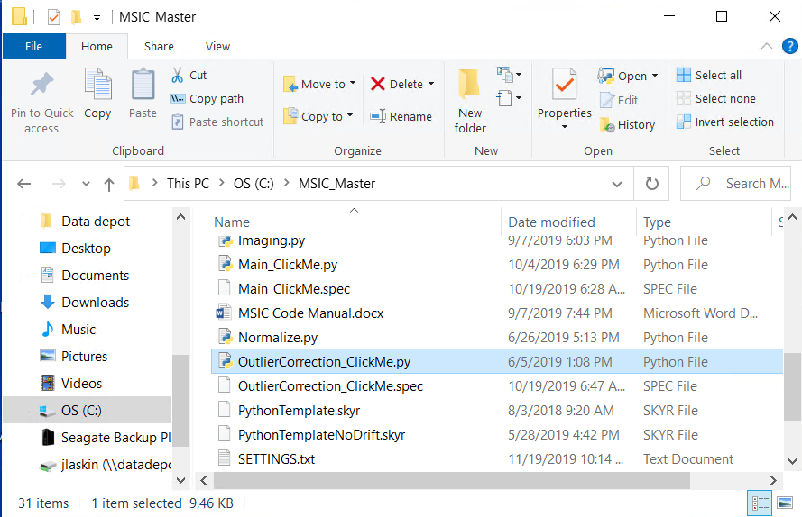

1. Use the pop up window to select the image you would like to de-spike
2. Select which algorithm you would like to use. And follow any algorithm specific input instructions  
   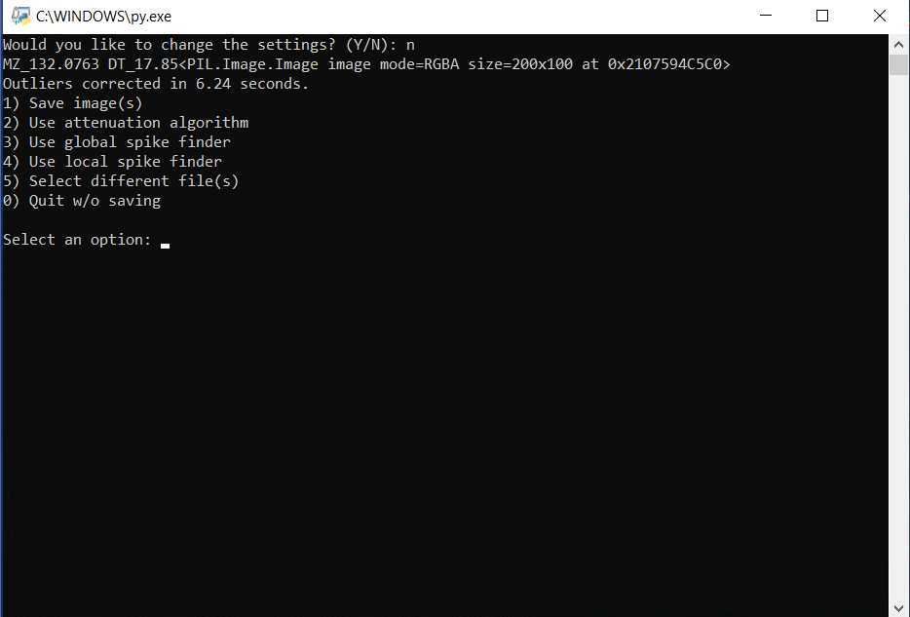
   1. Select if you would like to save your results or if you would like to add more images for a common normalization. Saved images will be saved in the data folder specified in the settings. You can change this when first launching the script or in the text file (A3).

## 3. RBG Overlay

Creates 1 image wherein each of the red, green, and blue channels for each pixel is determined by the relative intensity of a separate compound at a given point.

1. Launch the ***OutlierCorrection_ClickMe.py*** file from the MSIC_Master folder

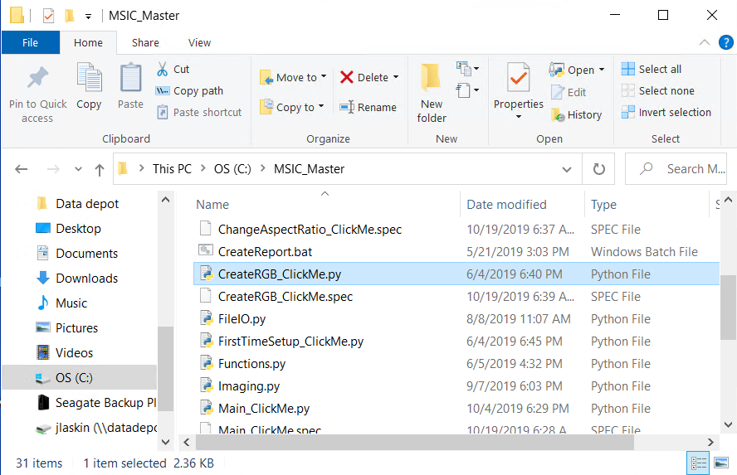

1. Use the pop up window to select 3 .txt files corresponding to MSIC images. The order that you input the images determines which one becomes red, which becomes blue, and which becomes green.
2. Choose to save your merged image. Saved images will be saved in the data folder specified in the settings. You can change this when first launching the script or in the text file (A3). You may also try again with a new set of images.   
   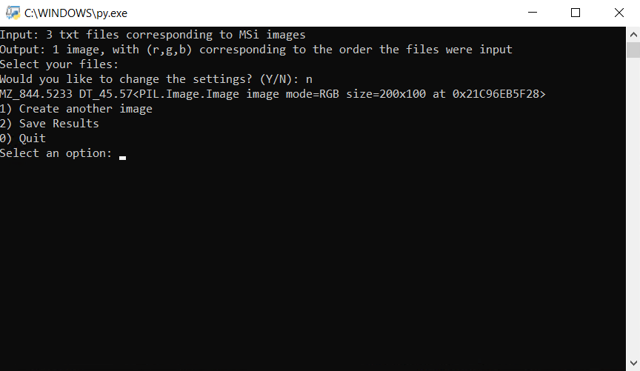

## 3. Change Aspect Ratio

1. Launch the ***ChangeAspectRatio_ClickMe.py*** file from the MSIC_Master folder
2. Select the Images folder within an experimental folder
3. Input your new aspect ratio

# D. Troubleshooting

## 1. Software versions

Make sure Python version is the same as your interpreter Python version, otherwise everything should work on the most up to date versions but, just in case, you can revert back to these tested versions

|  |  |
| --- | --- |
| **Software** | **Version** |
| Mass Profiler | B.08.01 8.1.150.0 |
| Skyline Daily | 4.1.1.18179 |
| SkylineDailyRunner | 3.5.1 |
| Python | 3.6.5 |
| Anaconda | 5.2 (for Python 3.6) |
| Spyder | 3.3.0 |

## 2. Path

1. Hit the windows key (or click the start button), search for ‘Edit the system environment variables,’ press enter or click on the entry
2. Click ‘Environment variables’ in the ‘System Properties’ menu that popped up
3. Double-click Path under User variables
4. You should have entries for Skyline-daily (ex. C:\Users\Steve\AppData\Roaming\Microsoft\Windows\Start Menu\Programs\Skyline-daily) and Python (ex. C:/Python36 or C:/Users/XXX/AppData/Local/Python/Python36) 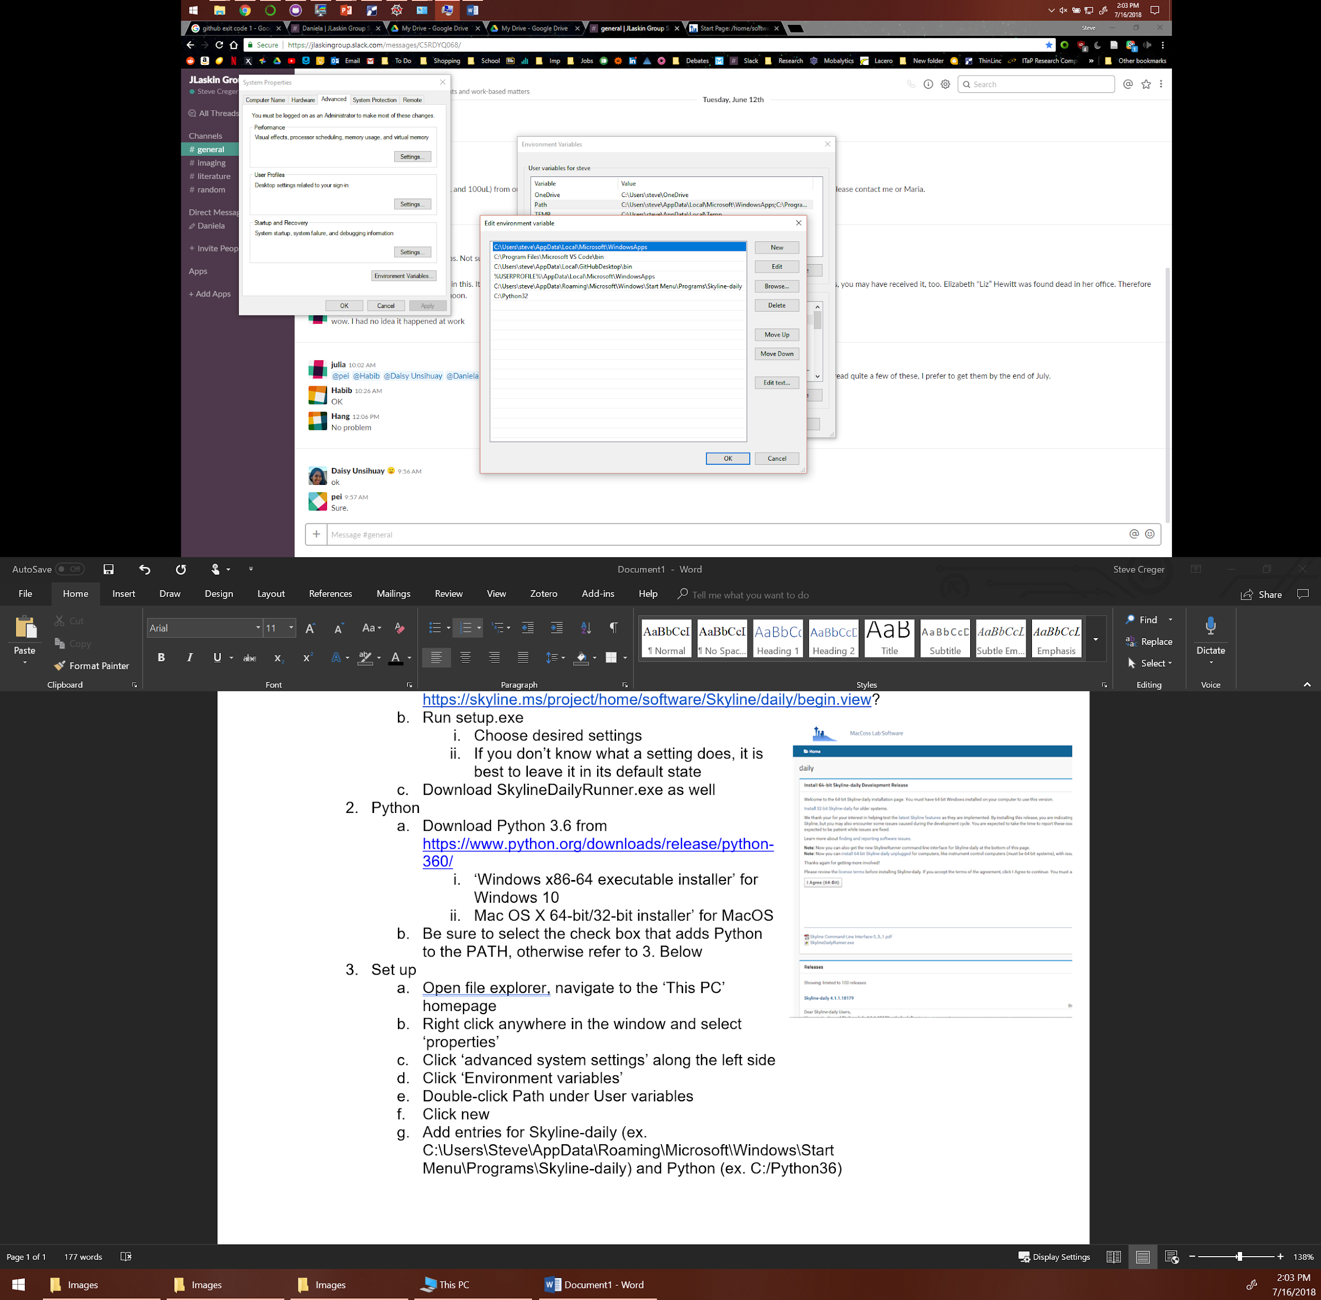
5. If you don’t: click new
6. Type the path to the desired program and hit enter
   1. To find the path, navigate to the folder/file in question in Windows File Explorer
   2. In the main toolbar, click 
   3. Paste the entry into the Path table, make sure to remove the “quotation marks”

## 3. Raw Data Directory Properties

1. Ensure there are no spaces anywhere in your path to your raw data folder.
2. The raw data folder should be present on a drive physically attached to your PC – internal/external HDD/SSD, flash drive, etc. The raw data folder should NOT be on a network drive – this can cause the script to throw out an error and exit.

1. Undergraduate student researchers.

   560 Oval Drive, West Lafayette,IN 47907-2084 · Email: jlaskin@purdue.edu